DESIGN OF ADC AND DAC CIRCUIT



***A Project Report for Summer Training***

***Submitted By,***

***Subudhi Anvesh (ECE 3rd Year, GIET University)***

***Dinesh Kumar Patnaik (ECE 3rd Year, GIET University)***

***May 2020-June 2020***

**BONAFIDE CERTIFICATE**

CERTIFIED THAT THIS PROJECT WORK WAS CARRIED OUT UNDER MY SUPERVISION

**“DESIGN OF ADC AND DAS CIRCUIT”** IS THE BONAFIDE WORKOF

1. Subudhi Anvesh
2. Dinesh Kumar Patnaik

**PROJECT MENTOR:**

**SIGNATURE**

**Ardent Original Seal**

**ACKNOWLEDGEMENT**

We take this opportunity to express our deep gratitude and sincerest thank to our project mentor, for giving most valuable suggestion, helpful guidance and encouragement in the execution of this project work.

Last but not the least I am grateful to all the faculty members of Ardent ComputechPvt. Ltd. for their support.

**INTRODUCTION**

In modern life, electronic equipment is frequently used in different fields such as communication, transportation, entertainment, etc. Analog to Digital Converter (ADC) and Digital to Analog Converter (DAC) are very important components in electronic equipment. Since most real world signals are analog, these two converting interfaces are necessary to allow digital electronic equipments to process the analog signals. Take the audio signal processing as an example, ADC converts the analog signal collected by audio input equipment, such as a microphone, into a digital signal that can be processed by computer. The computer may add sound effect such as echo and adjust the tempo and pitch of the music. DAC converts the processed digital signal back into the analog signal that is used by audio output equipment such as a speaker.

In electronics, an Analog to Digital Converter (ADC) is a device for converting an analog signal (current, voltage etc.) to a digital code, usually binary. In the real world, most of the signals sensed and processed by humans are analog signals. Analog-to-Digital conversion is the primary means by which analog signal are converted into digital data that can be processed by computers for various purposes.

There are many types of ADC for different applications. The most inexpensive type of ADC is a Successive-Approximation ADC. Inside a Successive-Approximation ADC, a series of digital codes, each corresponds to a fix analog level, are generated successively by an internal counter to compare with the analog signal under conversion. The generation is stopped when the analog level becomes just larger than the analog signal. The digital code corresponds to the analog level is the desired digital representation of the analog signal.

**OBJECTIVES**

The main purposes of this project are:

* To design an ADC and DAC circuit.
* Each input voltage to produce digital or binary form consisting of 1s and 0s in and **ADC**.
* The digital output from the computer is connected to a **DAC**, which converts it to a proportional analog voltage.
* Our task is also to design the ADC and DAC circuit using the DSCH.

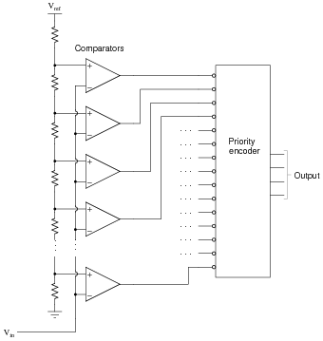

**ADC**

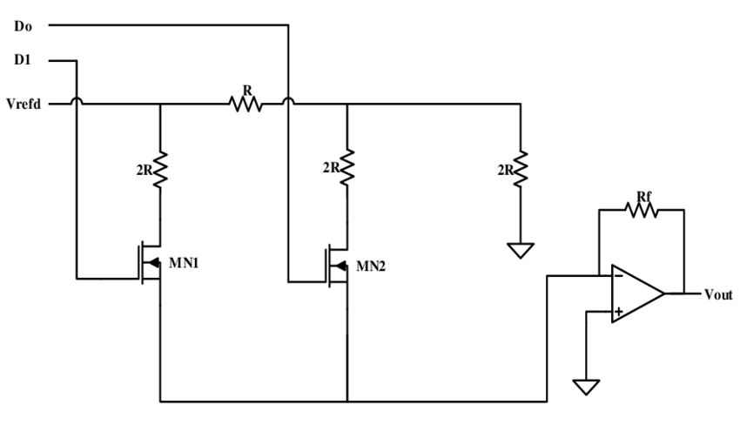

**DAC**

**What is DSCH??**

The DSCH program is a logic editor and simulator. DSCH is used to validate the architecture of the logic circuit before the microelectronics design is started. DSCH provides a user-friendly environment for hierarchical logic design, and fast simulation with delay analysis, which allows the design and validation of complex logic structures.  
DSCH also features the symbols, models and assembly support for 8051 and PIC16F84 controllers. Designers can create logic circuits for interfacing with these controllers and verify software programs using DSCH.

#### **Highlights**

* User-friendly environment for rapid design of logic circuits.
* Supports hierarchical logic design.
* Added a tool on fault analysis at the gate level of digital. Faults: Stuck-at-1, stuck-at-0.  
  The technique allows injection of single stuck-at fault at the nodes of the circuit.
* Improved interface between DSCH and Winspice.
* Handles both conventional pattern-based logic simulation and intuitive on screen mouse-driven simulation.
* Built-in extractor which generates a SPICE netlist from the schematic diagram  
  (Compatible with PSPICETM and WinSpiceTM).
* Generates a VERILOG description of the schematic for layout conversion.
* Immediate access to symbol properties (Delay, fanout).
* Model and assembly support for 8051 and PIC 16F84 microcontrollers.
* Sub-micron, deep-submicron, nanoscale technology support.
* Supported by huge symbol library

**USED TOOLS AND SOFTWARES**

1. DSCH – 3.

**DESIGN**

**Analog-Digital Converter**

The analog-digital converter converts an analog value Vin into a two-bit digital value. The flash converter uses three converters and a coding logic to produce output. The polysilicon has a high resistance and can be used as a resistor network, which generates intermediate voltage references used by the voltage comparators located in the middle. The resistance symbol is inserted in the layout to indicate to the simulator that an equivalent resistance must be taken into account for the analog simulation. Open-loop amplifiers are used as voltage comparators. The comparisons address the decoding logic situated to the right and that provides correct coding.

**Digital-Analog Converter**

The digital-analog converter converts a digital input into an analog value Vout. The polysilicon resistive net gives intermediate voltage references which flow to the output via a transmission gate net. The resistance symbol is inserted in the layout to indicate to the simulator that an equivalent resistance must be taken into account for the analog simulation.

**DESCRIPTION, EVALUATION OF EACH BLOCK OF 4-BIT ADC AND DAC WITH CIRCUIT DIAGRAM AND OUTPUT:**

**ADC**

**Op-Amp –**

Op amps are often used as drivers for ADCs to provide the gain and level-shifting required for the input signal to match the input range of the ADC. An op amp may be required because of the antialiasing filter impedance matching requirements. In some cases, the antialiasing filter may be an active filter and include op amps as part of the filter itself. Some ADCs also generate transient currents on their inputs due to the conversion process, and these must be isolated from the signal source with an op amp. This section examines these and other issues involved in driving high performance ADCs.

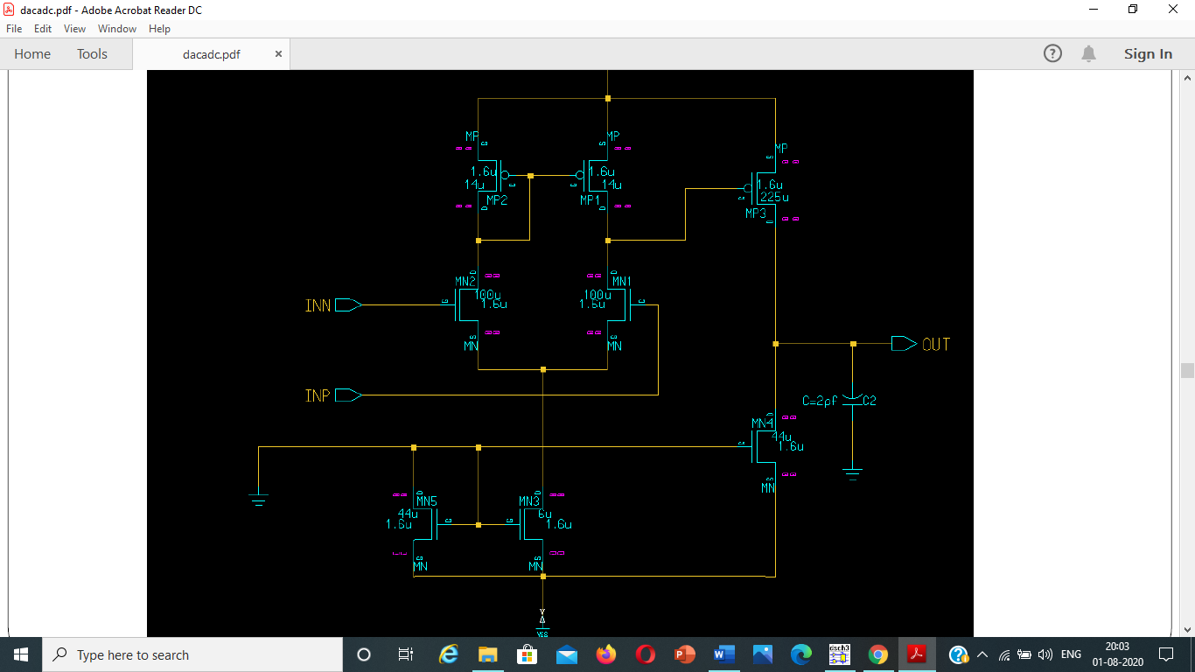

**Simulation Op amp –**

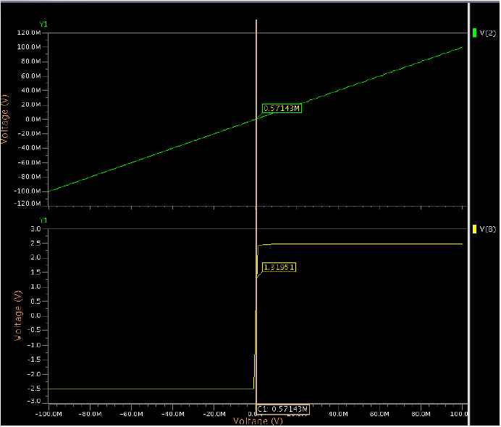

**Latch –**

In order to distinguish the latch used as a comparator from

the latch functioning as a pure digital storage element, the latch

used for the comparator is hereafter referred to as a dynamic

latch. Unlike the preampliﬁer, the dynamic latch is not a linear

circuit for input voltage, because its output eventually reaches

a logic high or low level depending only on the input polarity

In order to distinguish the latch used as a comparator from

the latch functioning as a pure digital storage element, the latch

used for the comparator is hereafter referred to as a dynamic

latch. Unlike the preampliﬁer, the dynamic latch is not a linear

circuit for input voltage, because its output eventually reaches

a logic high or low level depending only on the input polarity

In order to distinguish the latch used as a comparator from

the latch functioning as a pure digital storage element, the latch

used for the comparator is hereafter referred to as a dynamic

latch. Unlike the preampliﬁer, the dynamic latch is not a linear

circuit for input voltage, because its output eventually reaches

a logic high or low level depending only on the input polarity

In order to distinguish the latch used as a comparator from

the latch functioning as a pure digital storage element, the latch

used for the comparator is hereafter referred to as a dynamic

latch. Unlike the preampliﬁer, the dynamic latch is not a linear

circuit for input voltage, because its output eventually reaches

a logic high or low level depending only on the input polarity

Latch used as a comparator from the latch functioning as a pure digital storage element, the latch used for the comparator is hereafter referred to as a dynamic latch. Unlike the preampliﬁer, the dynamic latch is not a linear circuit for input voltage, because its output eventually reaches a logic high or low level depending only on the input polarity.

Latches are the basic elements for storing information. One latch can store one bit of information. The main difference between latches and flip-flops is that for latches, their outputs are constantly affected by their inputs as long as the enable signal is asserted. In other words, when they are enabled, their content changes immediately when their inputs change.

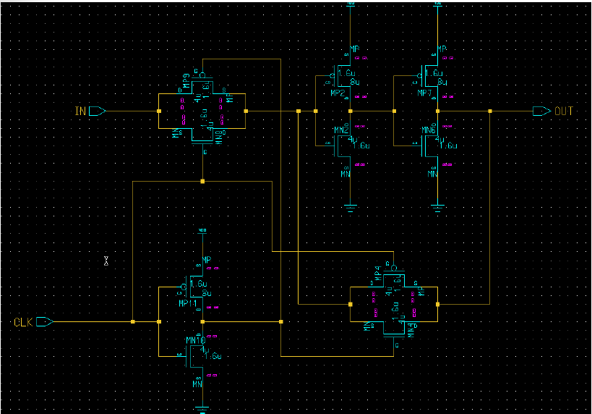

There are basically 4 main types of latches: SR,T,JK and D.

**1.SR Latch:**

The bistable element is able to remember or store one bit of information. However, because it does not have any inputs, we cannot change the information bit that is stored in it. In order to change the information bit, we need to add inputs to the circuit. The simplest way to add inputs is to replace the two inverters with two NAND gates. This circuit is called a SR latch.

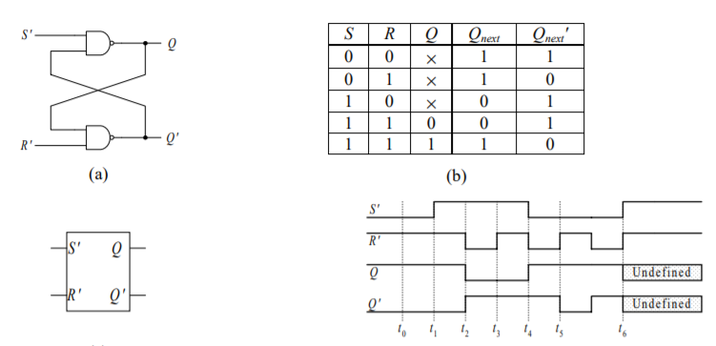

**2.D Latch:**

The disadvantage with the SR latch is that we need to ensure that the two inputs, S and R, are never de-asserted at the same time. This situation is prevented in the D latch by adding an inverter between the original S and R inputs and replacing them with just one input D (for data) Notice that the placement of the inverter with respect to the Q output is such that the Q output value follows the D input. This feature is useful because, whereas the SR latch is useful for setting or resetting a flag on a given condition, the D latch is useful for simply storing a bit of information that is presented on a line.

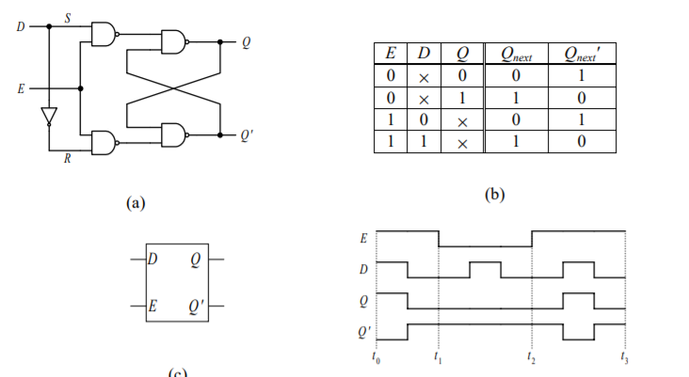

### **3.JK Latch:**

The both**JK latch**, as well as RS latch, is similar. This latch comprises two inputs namely J and K which are shown in the following logic gate diagram. In this type of latch, the unclear state has been removed here. When the JK latch inputs are high, the output will be toggled. The only difference we can observe here is the output feedback toward inputs, which is not present in the RS-latch.

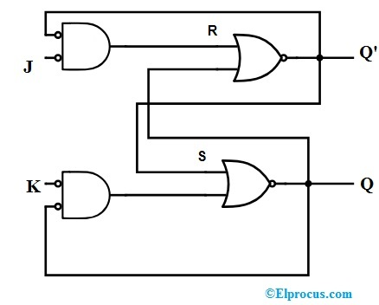

### **4.T Latch:**

The **T latch** can be formed whenever the JK latch inputs are shorted. The function of T Latch will be like this when the input of the latch is high, and then the output will be toggled.

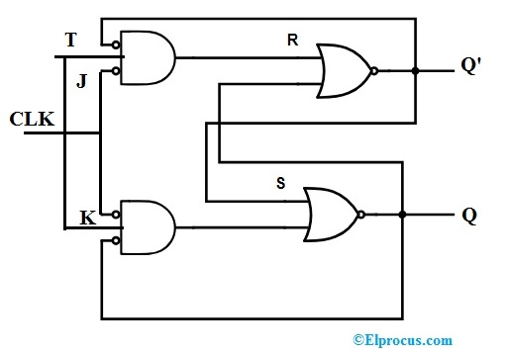

**Simulation Latch –**

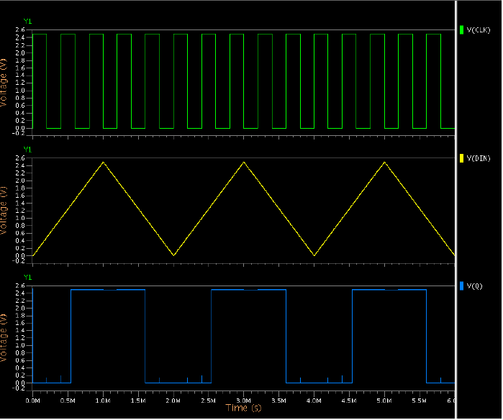

**Comparator: op amp + latch –**

An operational amplifier (op-amp) has a well balanced difference input and a very high gain. This parallels the characteristics of comparators and can be substituted in applications with low-performance requirements.

A comparator circuit compares two voltages and outputs either a 1 (the voltage at the plus side; VDD in the illustration) or a 0 (the voltage at the negative side) to indicate which is larger. Comparators are often used, for example, to check whether an input has reached some predetermined value. In most cases a comparator is implemented using a dedicated comparator IC, but op-amps may be used as an alternative. Comparator diagrams and op-amp diagrams use the same symbols.

The comparator is a major block used in the flash ADC for analog to digital conversion. The use of comparators count is varied depends on the resolution of the flash ADC. Comparator count increases as 2n for an n-bit resolution flash ADC.

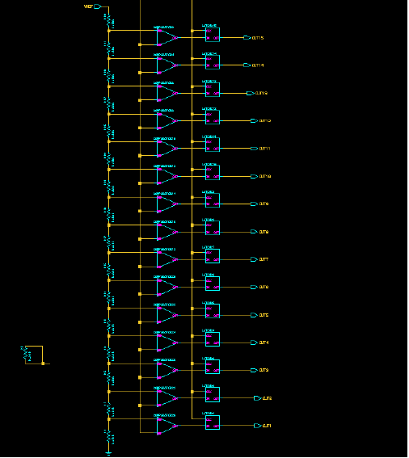

Circuit Diagram of Comparator

**Simulation Comparator ­–**

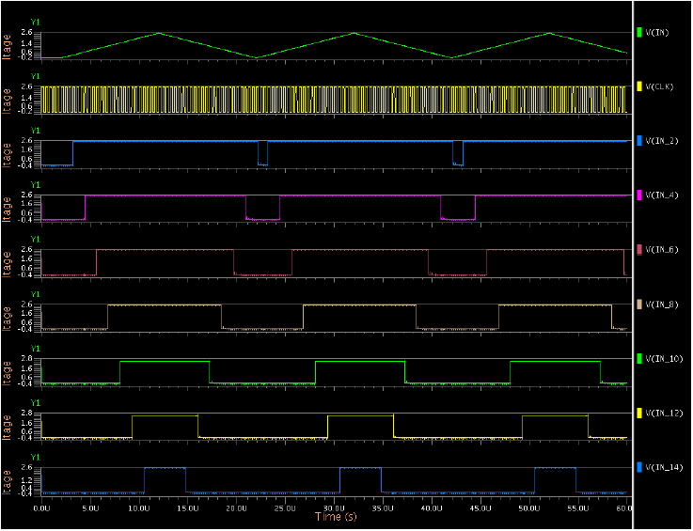

**Encoder –**

An Encoder is a combinational circuit that performs the reverse operation of Decoder. It has maximum of 2n input lines and ‘n’ output lines. It will produce a binary code equivalent to the input, which is active High. Therefore, the encoder encodes 2n input lines with ‘n’ bits. It is optional to represent the enable signal in encoders.

There are two main types of digital encoder. The Binary Encoder and the Priority Encoder.

We have seen that the Binary Encoder converts one of 2n inputs into an n-bit output. Then a binary encoder has fewer output bits than the input code. Binary encoders are useful for compressing data and can be constructed from simple AND or OR gates.One of the main disadvantages of a standard binary encoder is that it would produce an error at its outputs if more than one input were active at the same time. To overcome this problem priority encoders were developed.

The Priority Encoder is another type of combinational circuit similar to a binary encoder, except that it generates an output code based on the highest prioritised input. Priority encoders are used extensively in digital and computer systems as microprocessor interrupt controllers where they detect the highest priority input.

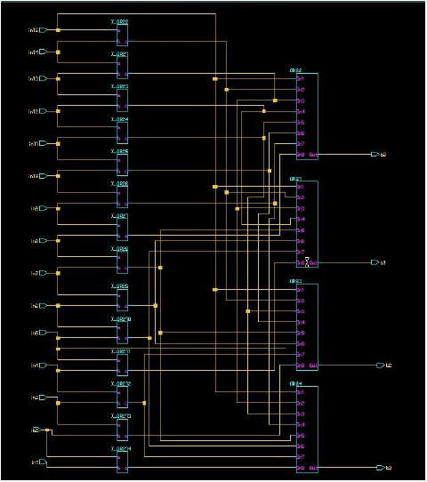

Circuit Diagram of Encoder

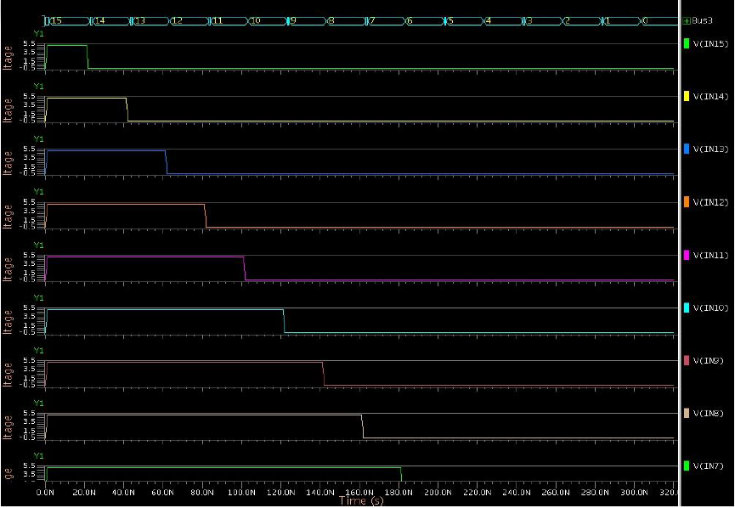**Simulation Encoder –**

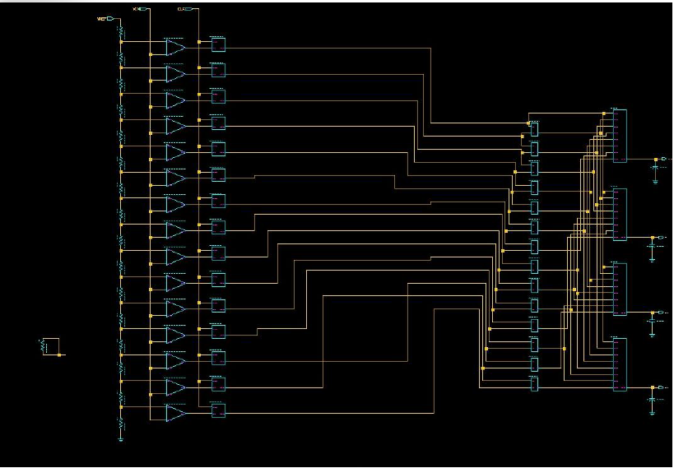**Complete ADC –**

**Simulation ADC –**

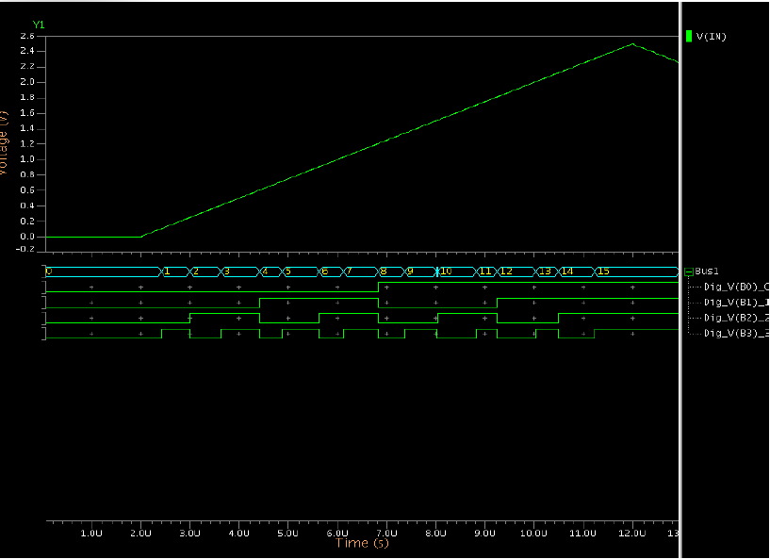

**ADC Specification –**

* **Comparator-stage:**

1. 8x15=120 transistors
2. 19 resistors
3. 15 capacitors

* **Latch**: 8x15=120 transistors
* **Encoder-stage**: 28x3+12x14=252 transistors

**ADC (total):**

1. 492 transistors
2. 19 resistors
3. 15 capacitors

**DAC-**

In electronics, a digital-to-analog converter (DAC, D/A, D2A, or D-to-A) is a system that converts a digital signal into an analog signal. An analog-to-digital converter (ADC) performs the reverse function.

There are several DAC architectures; the suitability of a DAC for a particular application is determined by figures of merit including: resolution, maximum sampling frequency and others. Digital-to-analog conversion can degrade a signal, so a DAC should be specified that has insignificant errors in terms of the application.

DACs are commonly used in music players to convert digital data streams into analog audio signals. They are also used in televisions and mobile phones to convert digital video data into analog video signals which connect to the screen drivers to display monochrome or color images. These two applications use DACs at opposite ends of the frequency/resolution trade-off. The audio DAC is a low

frequency, high-resolution type while the video DAC is a high-frequency low- to medium-resolution type.

Due to the complexity and the need for precisely matched components, all but the most specialized DACs are implemented as integrated circuits (ICs). These typically take the form of metal–oxide–semiconductor (MOS) mixed-signal integrated circuit chips that integrate both analog and digital circuits.

Discrete DACs (circuits constructed from multiple discrete electronic components instead of a packaged IC) would typically be extremely high-speed low-resolution power-hungry types, as used in military radar systems. Very high-speed test equipment, especially sampling oscilloscopes, may also use discrete DACs.

**R-2R DAC –**

The R-2R resistor ladder network directly converts a parallel digital symbol/word into an analog voltage. Each digital input (b0, b1, etc.) adds its own weighted contribution to the analog output. This network has some unique and interesting properties.

* Easily scalable to any desired number of bits
* Uses only two values of resistors which make for easy and accurate fabrication and integration
* Output impedance is equal to R, regardless of the number of bits, simplifying filtering and further analog signal processing circuit design.

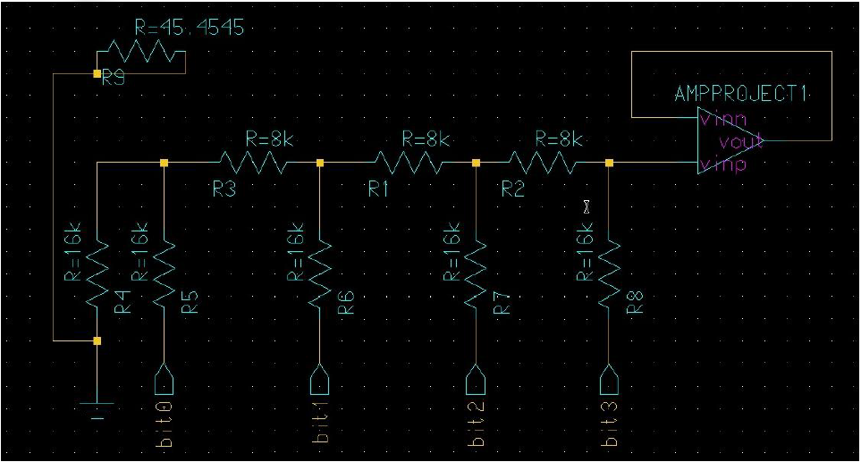

**R-2R DAC Simulation –**

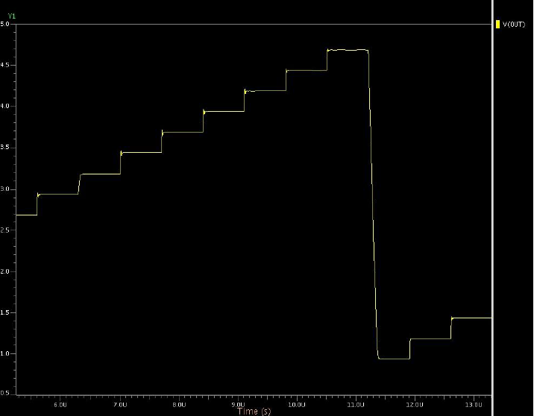

**Charge Scaling DAC –**

Charge scaling DACs operate by binary dividing of the total charge applied to a capacitor array. This process is implemented by using capacitor to attenuate the reference voltage. Advantage of charge scaling DAC is that it is compatible with switched capacitor circuits.

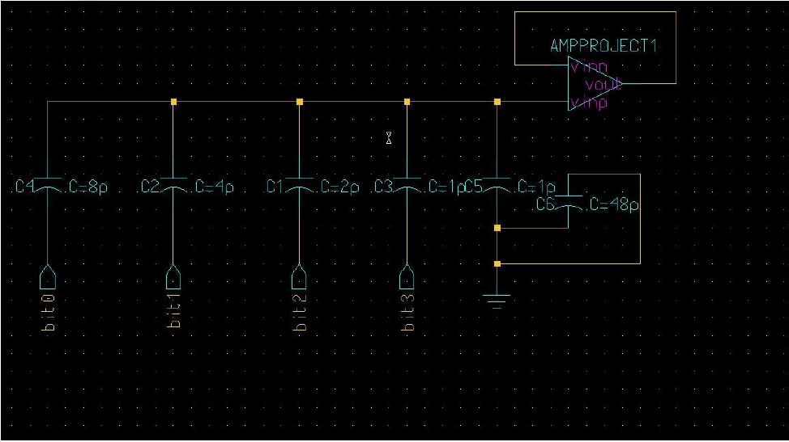

**Charge Scaling DAC Simulation –**

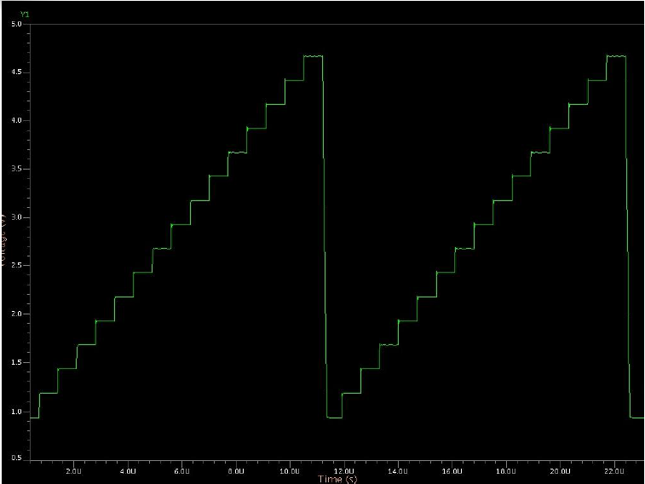

**DAC Specification:**

DAC

* R-2R DAC:

1. 7 transistors
2. 10 resistors
3. 1 capacitor

* Charge Scaling DAC:

1. 7 transistors
2. 1 resistor
3. 7 capacitors

### **Conclusion:**

Thus, with help of encoder, latches, comparator (resistors, capacitors, transistors), we are able to make an ADC and DAC circuit. The ADC and DAC circuit created can convert analog signals into its corresponding binary values and vice-versa. Thus, we have been successful in making an ADC and DAC circuit from the smallest bit that is required.

* We have designed an ADC and DAC circuit to handle two inputs of 4 bits.
* Each input voltage to produce digital or binary form consisting of 1s and 0s in an ADC.
* The digital output from the computer is connected to a DAC, which converts it to a proportional analog voltage.
* Our task is also to design and implement the ADC and DAC circuit using DSCH-3.8.